IBM Bluemix cloudantDB and Sterling Connect:Direct integration

Authors: | Mehmet Cambaz
Version: | 1.0
Date Created: | 04.10.2017
Last Updated: | 15.10.2017

Disclaimer:
The information contained herein is proprietary to IBM. The recipient of this document, by its retention and use, agrees to protect the information contained herein. Readers are advised that this project may be subject to the terms of a non-disclosure agreement. Do not disclose any of this information without obtaining permission from the management responsible for this document. All of the information is given “as-is” basis and author do not give any kind of guarantee of any sort, use it as your own risk.
Document Revision History
Revision | Date | Description | Author
1.0 | 15.10.2017 | First Draft | Mehmet Cambaz

Document Approval History
Name | Signature | Date | Version Approved/Comments

Reference Documents
Document Name | Description | Owner | Location

Table of Contents
- Introduction
- Content

- Introduction
This document’s purpose is to give helpful information on how to integrate IBM Sterling Connect:Direct with IBM Bluemix to show capabilities of an on-premise software such as Sterling Connect:Direct could be used in Hybrid Cloud environments such as IBM Bluemix via REST APIs.

The components that are used to demonstrate a use case which is a step in a Sterling Connect:Direct process assuming that a file is copied to PNODE and all the JSON (JSON is lightweight data format that is used in REST APIs. For more details see: http://www.json.org/ ) transformations are done (It can be done via IBM Transformation Extender) and the content is ready to send to IBM Bluemix CloudantDB via REST API.
- IBM Bluemix, you need a trial or paid subscription to use Bluemix capabilities. IBM Technical Sales Specialists (CSPs) are eligible to 365 days free trial subscription when they register via their ibm email. It might take couple of days for your account to be approved. Register link: https://console.bluemix.net/registration/
- IBM Sterling Connect:Direct for Windows v4.7 (latest) , could be installed to a virtual machine. Connect:Direct software could be downloaded from internal IBM website here: https://w3-03.ibm.com/software/xl/download/ticket.wss
- Curl for command line based REST API processing, could be publicly downloaded from here: https://curl.haxx.se/ (command line tool and library for transferring data with URLs)
After downloading the relevant curl version, you can unzip and copy the “bin” folder to your virtual machine’s C: folder so that you can use C:\bin as path to use curl
- IBM Bluemix Cloudant (Cloudant NoSQL DB provides access to a fully managed NoSQL JSON data layer that's always on. This service is compatible with CouchDB, and accessible through a simple to use HTTP interface for mobile and web application models) database, an instance could be created from: https://console.bluemix.net/catalog/?category=data
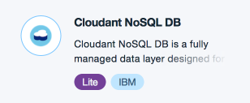
Select pricing as Lite since it is free for IBM CSPs and is enough for the use case. 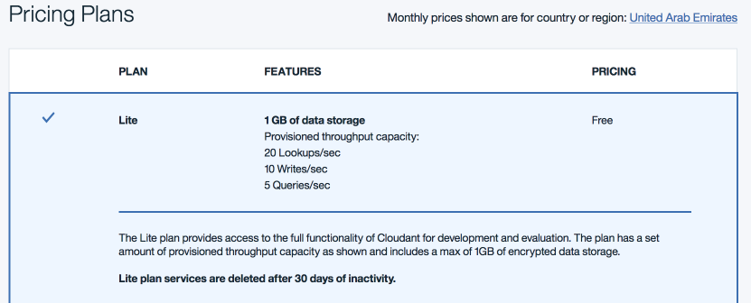

After you create the database instance itself, you could create the database you will use in this document from the bluemix management user interface. To open the cloudantDB:
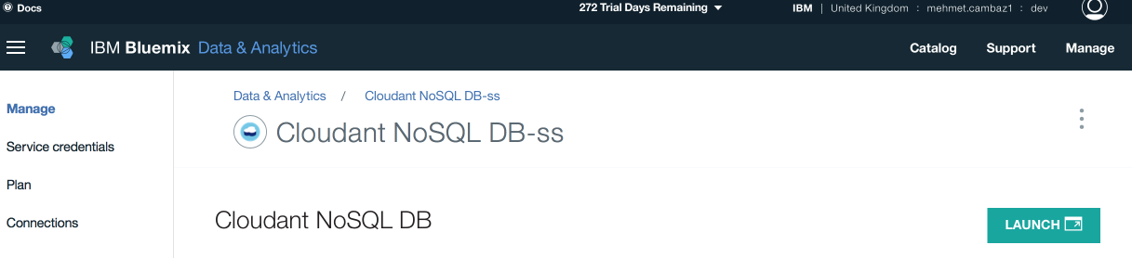
Click “Launch”
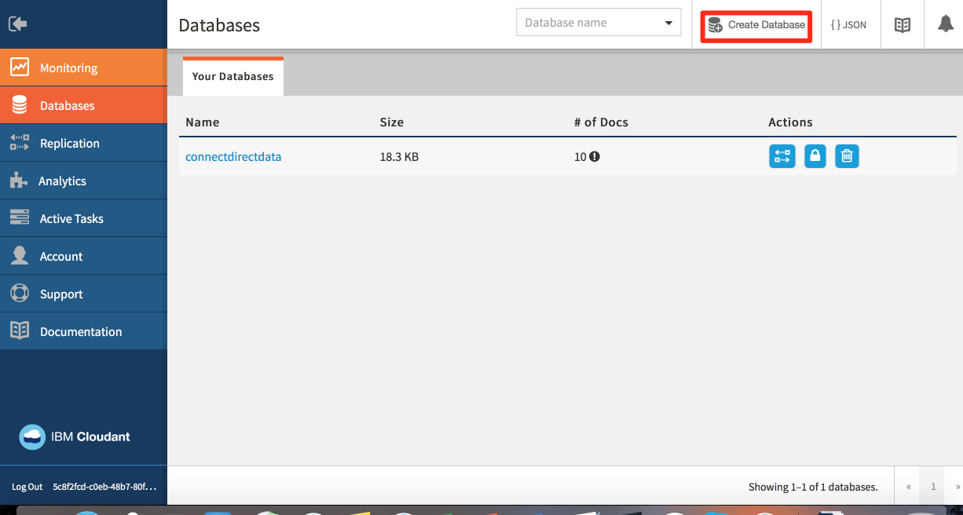
Click “Create Database” and give the database name “connectdirectdata”
You can see the contents of the database like this:
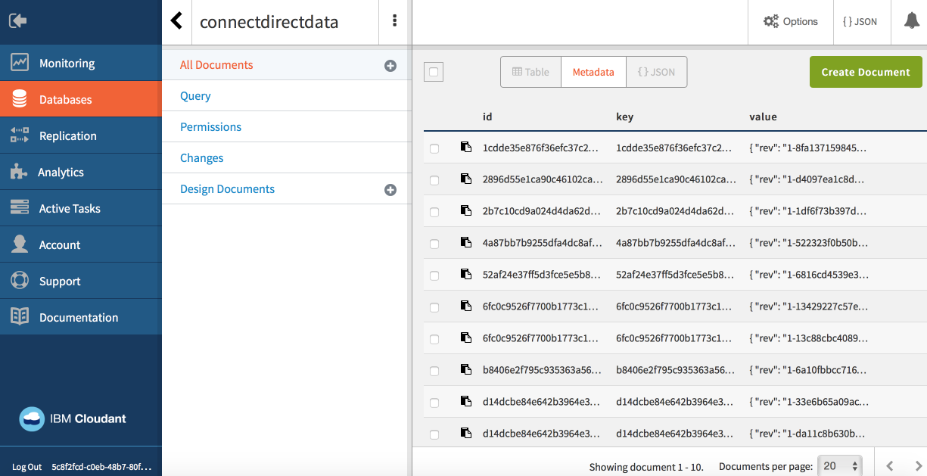
To give access to your application via API key and password, click “Permissions”
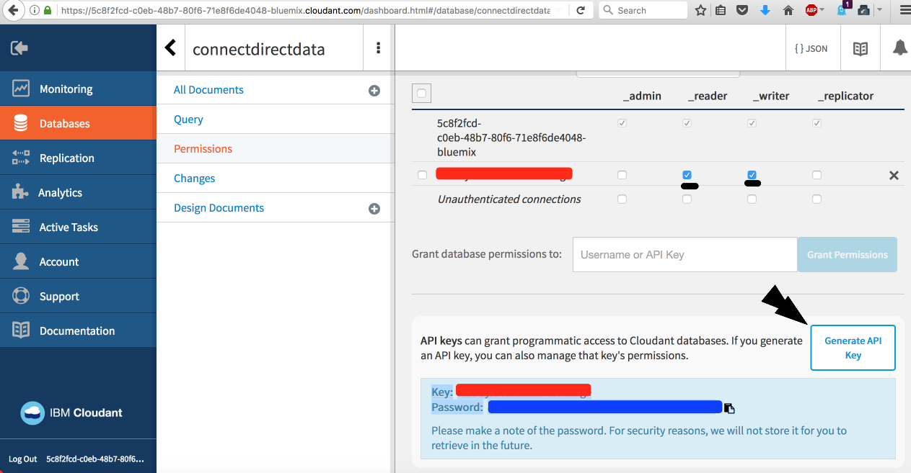
Then click “Generate API Key”, also give that key _reader and _writer access so that it can do CRUD operations to the database. It will give key and password you will use these two information to connect to this database.

- Content

Sterling Connect:Direct can call the REST APIs CloudantDB provides via command line execution leveraging the curl libraries and executables. Sample curl usage for json POST action:

curl -H "Content-Type: application/json" -X POST -d '{"username":"xyz","password":"xyz"}' http://localhost:3000/api/login

blue is the json data part
red is the url part to post

When using windows OS (which is the case for the sample virtual machine I used) the escape characters should included in \ for example:

curl -X POST -H "Content-Type: application/json" -d "{ \"key1\": \"value1\" }" http://localhost:3000/api/method

See more details here: https://stackoverflow.com/questions/7172784/how-to-post-json-data-with-curl-from-terminal-commandline-to-test-spring-rest

At our sample with CloudantDB the right script for json POST is this:
C:\bin\curl --user APIKEYGENERATED:APIKEYPASSWORD -X POST -H "Content-Type: application/json" -d JSONDATA https://YOURCLOUDANTINSTANCEID-bluemix.cloudant.com/connectdirectdata/

This command will insert the JSONDATA provided to the database as a record.
In order to make things more simple we will add this script to batch script file ending with .bat and add some variable as JSONDATA to get another file’s content to JSONDATA.

for /f "delims=" %%x in (C:\bin\input.txt) do set Build=%%x
C:\bin\curl --user APIKEYGENERATED:APIKEYPASSWORD -X POST -H "Content-Type: application/json" -d %Build% https://YOURCLOUDANTINSTANCEID -bluemix.cloudant.com/connectdirectdata/

Line 1 script in yellow is to get the input file’s content (C:\bin\input.txt in this case) to variable Build. This variable will be used in line 2 as %Build% which JSONDATA to be inserted into the database.
We save this script to C:\bin\ as postwithcurl.bat
As input sample JSONDATA, we save the below content to C:\bin\ as input.txt

"{\"company\":\"bank16\",\"feedback\":\"i have no comment\"}"

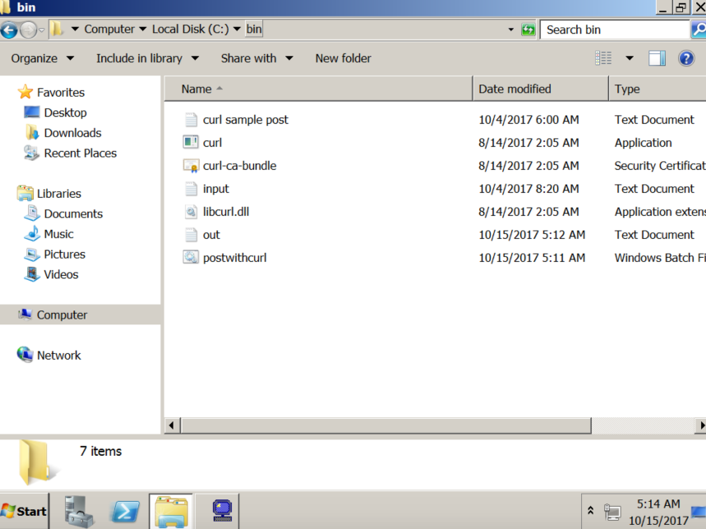
In order to execute this batch file reading the file content of input.txt and posting the info via curl to CloudantDB as a record we will use Sterling Connect:Direct process like this:
(For more information on Connect:Direct processes: https://www.ibm.com/support/knowledgecenter/en/CD_PROC_LANG/com.ibm.help.cdprocoverview.doc/cdprc_over_what_is_a_cd_process.html )

BMTEST1 PROCESS
SNODE=CDW2008
PNODEID=(Administrator,passw0rd)
SNODEID=(Administrator,passw0rd)
BMJOB1 RUN JOB PNODE (DSN=Windows)
SYSOPTS="cmd(C:\bin\postwithcurl.bat >> c:\bin\out.log 2>~&1)"
PEND

At this Connect:Direct process we use the submit job step to execute the batch file we prepared and using some scripting to generate logs about the action.

BMJOB1 RUN JOB PNODE (DSN=Windows)
SYSOPTS="cmd(C:\bin\postwithcurl.bat >> c:\bin\out.log 2>~&1)"

DSN=Windows means that this job is a Windows job execution
SYSOPTS=”cmd()” means that it will run windows command line which is cmd.exe
At the windows command line, it will execute the command below:
C:\bin\postwithcurl.bat >> c:\bin\out.log 2>~&1
Which means executing the batch file and appends the outputs to C:\bin\out.log file

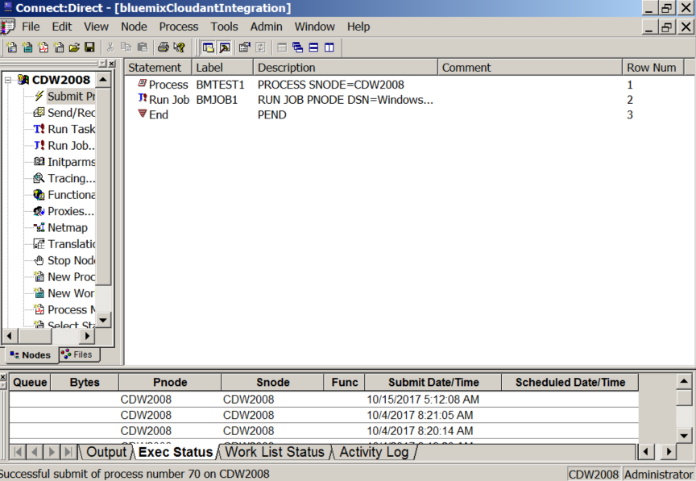
you can right click and click the “Edit/View Text” to see the Connect:Direct process source code
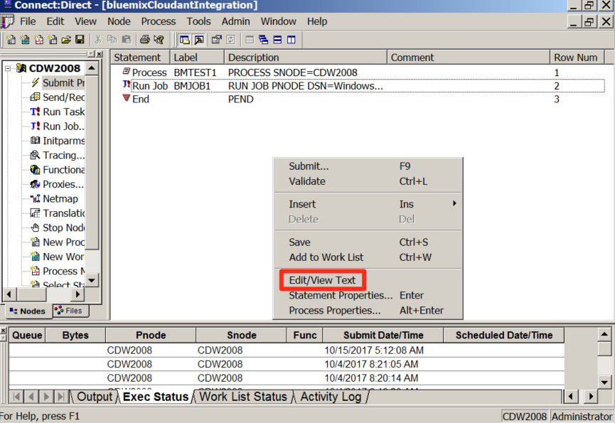

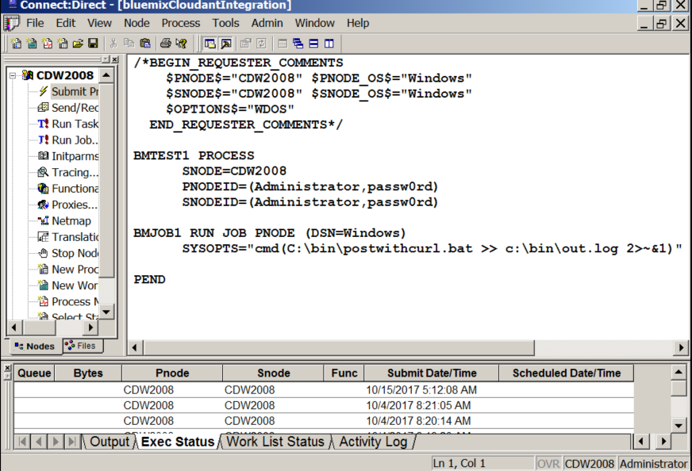

We will submit this process via right click to process and click the “Submit Process” menu item

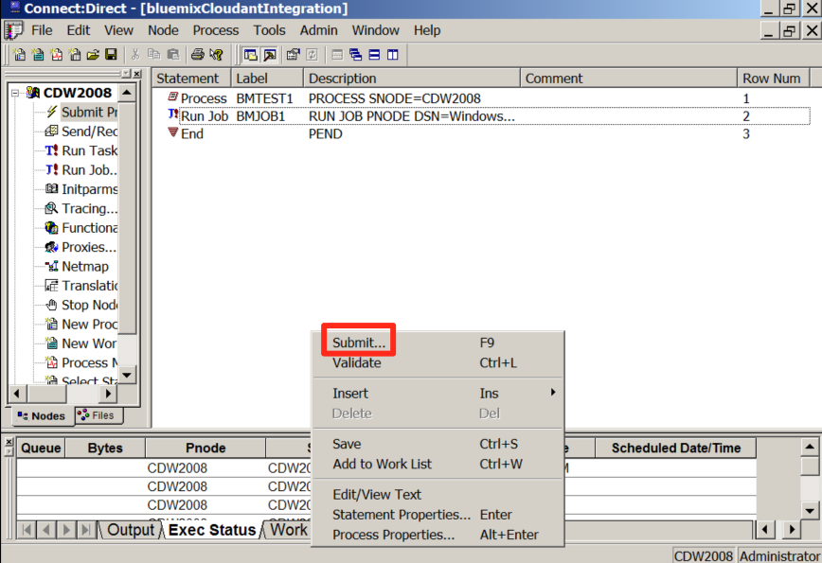

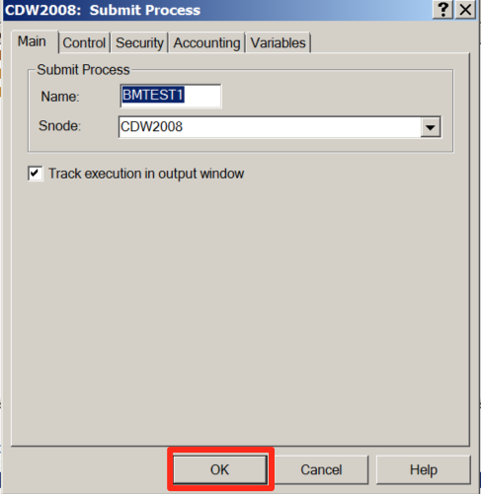

In order to see what was the outcome of the process you can right click the submitted process and click “View Details”:
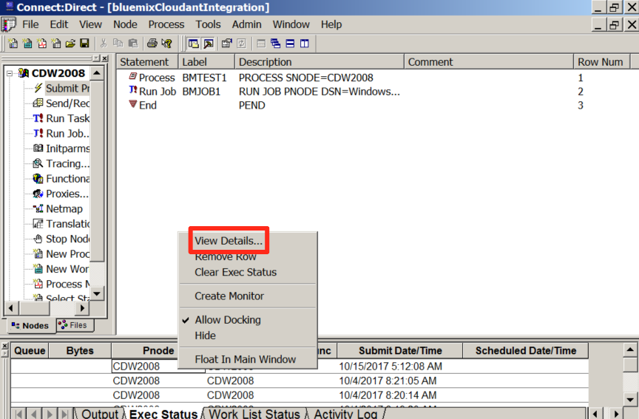

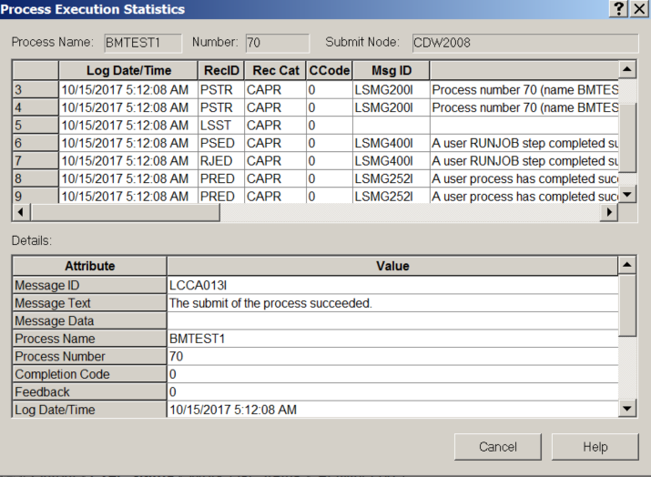

It is important check if all the steps completed successfully.

Now we can check the application logs we had scripted in out.log file content:

C:\Program Files (x86)\Sterling Commerce\Connect Direct v4.7.0\Server\Program>for /F "delims=" %x in (C:\bin\input.txt) do set Build=%x

C:\Program Files (x86)\Sterling Commerce\Connect Direct v4.7.0\Server\Program>set Build="{\"company\":\"bank16\",\"feedback\":\"i have no comment\"}"

C:\Program Files (x86)\Sterling Commerce\Connect Direct v4.7.0\Server\Program>C:\bin\curl --user APIKEY:APIKEYPASSWORD -X POST -H "Content-Type: application/json" -d "{\"company\":\"bank16\",\"feedback\":\"i have no comment\"}" https://YOURCLOUDANTINSTANCEID-bluemix.cloudant.com/connectdirectdata/
% Total % Received % Xferd Average Speed Time Time Time Current
Dload Upload Total Spent Left Speed
0 0 0 0 0 0 0 0 --:--:-- --:--:-- --:--:-- 0100 146 100 95 100 51 95 51 0:00:01 --:--:-- 0:00:01 166100 146 100 95 100 51 95 51 0:00:01 --:--:-- 0:00:01 166{"ok":true,"id":"61690d7761073fd5d788abb459dcb14d","rev":"1-8fa137159845b97eff131ced1f2f8c22"}

As you can see the script read the input.txt file content which was:

"{\"company\":\"bank16\",\"feedback\":\"i have no comment\"}"

and done a REST API post to Cloudant DB and the REST API response was successful, it returned the record item ID:

{"ok":true,"id":"61690d7761073fd5d788abb459dcb14d","rev":"1-8fa137159845b97eff131ced1f2f8c22"}

When we check it out the relevant record from the CloudantDB the record is there:

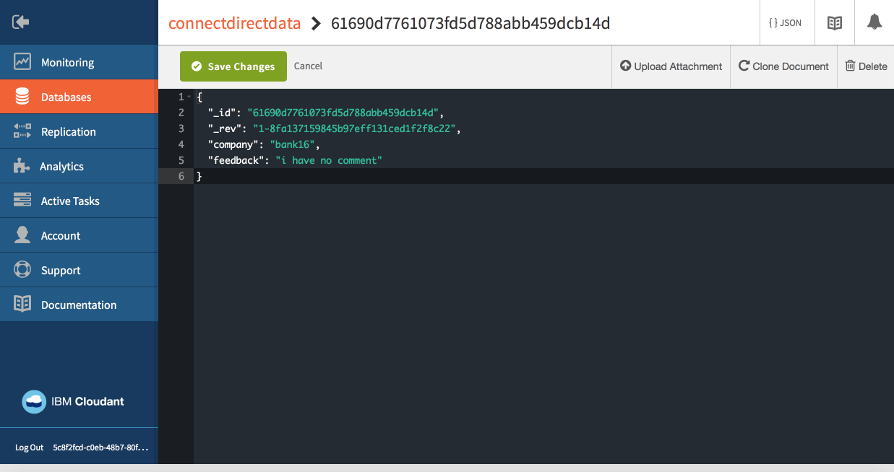

In summary; this exercise shows that IBM Sterling Connect:Direct could be used to integrate with public, hybrid or private cloud environments easily and it is possible to send file content/record rows/items etc. to databases/application with REST APIs. This also proves that it could be used in cognitive solutions.

